**CS 210 Project Proposal**

The integration of social media into our lives in today’s world has not only revolutionized communication in society but also had significant impacts on finance. Crypto Currency had become one of the most essential parts of financial markets. The clicks and the extensive discussions which led to crypto currencies become trends on social media platforms such as Twitter or Facebook are causing changes in the value of trending cryptocurrency and increased the transaction volume. This project proposes an expletory data analysis to investigate the cause effect relationship between social media trends, especially Twitter trend and clicks, and subsequent volume and price fluctuation of cryptocurrency.

The project will focus on exploring the dynamic relationship between crypto currencies in stock market and social media. The hypothesis suggests that crypto assets which attract significant attention and go viral on social media, lead to vital changes in their transaction volume and values in stock market. In the initial stage of testing hypothesis process, major changes in the transaction volumes and values of cryptocurrencies in stock market dataset will be analyze and visualized.

The histograms of frequency and volume for “Bitcoin” and “Ethereum” represent the major change in volume from stock market dataset for the period 18-02-2022 to 14-03-2022. The expected outcome is that the trends and clicks related with these crypto currencies on social media is the cause of this event.

metin, ekran görüntüsü, çizgi, öykü gelişim çizgisi; kumpas; grafiğini çıkarma içeren bir resim

Açıklama otomatik olarak oluşturuldu

metin, ekran görüntüsü, çizgi, öykü gelişim çizgisi; kumpas; grafiğini çıkarma içeren bir resim

Açıklama otomatik olarak oluşturuldu

The scatter plots of Bitcoin and Ethereum Prices from 15-09-2021 to 15-11-2021 taken from stock market dataset represent the changes of values in stock market. The expected outcome is that the trends and clicks related with these crypto currencies on social media is the cause of this event.

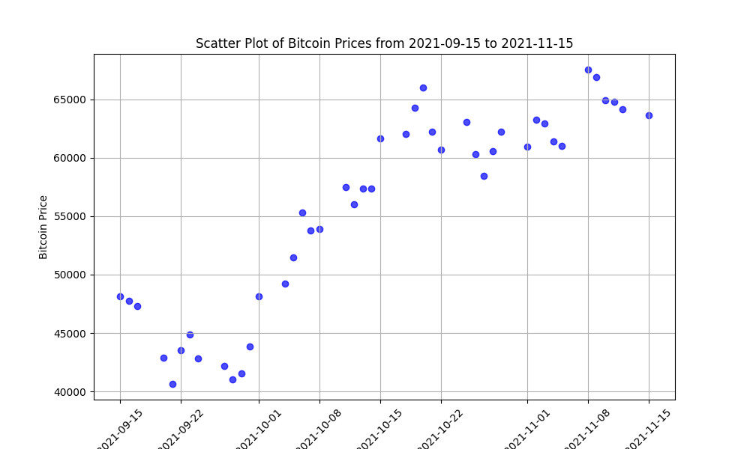

metin, diyagram, öykü gelişim çizgisi; kumpas; grafiğini çıkarma, çizgi içeren bir resim

Açıklama otomatik olarak oluşturuldu

In the project, it is expected that cryptocurrencies which are in the dataset, will become trending on social media and have higher click rates than usual leads to anomalies in both in their values and transaction volumes. During the testing stages of the hypothesis, the potential stocks from the stock market dataset could directly affect cryptocurrency will examine by using ML models, along with social media dataset. Major changes in cryptocurrencies will be analyzed and reach a conclusion.

Yağız Uçar

31204